

**Jamhuri ya Muungano wa Tanzania**

**Wizara ya Kilimo**

**Sehemu ya Masoko ya Mazao ya Kilimo**

**Taarifa ya Wiki ya Mwenendo wa Bei za Mazao** **21 - 25 Oktoba 2024**

**Jedwali 1: Wastani wa bei za jumla Kitaifa (TZS/ kil**

***Ujumbe Mkuu***

***Mazao makuu ya chakula***

*Bei za jumla*

*:*

*zimebadilika kwa viwango tofauti ikilinganishwa na viwango vya wastani wa bei za wiki iliyopita. Bei*

*ya*

*uwele*

*imepungua*

*kwa*

*asilimia 5.9*

*wakati*

*bei z*

*a*

*mahindi, mchele,*

*maharage, mtama*

*,*

*ulezi*

*na viazi mviringo*

*hazijabadilika.*

***Kakao:***

*Hadi kufikia*

*tarehe*

*21*

*Okto*

*ba, 2024 kakao iliyouzwa kwa msimu wa mauzo 2024/2025 ni kilo*

3,617,250.0

*zenye*

*thamani ya Shilingi*

*Bilioni*

*71*

*.*

***Kahawa***

*:*

*Hadi kufikia*

*tarehe 18*

*Okto*

*ba, 2024 kahawa iliyouzwa kwa msimu wa mauzo 2024/2025 ni kilo*

*32,214,535*

*zenye*

*thamani ya Dola za*

*Marekani Milioni*

*1*

*36*

*.*

|  |  |  |  |  |  |  |  |  |
| --- | --- | --- | --- | --- | --- | --- | --- | --- |
| Wiki iliyopita | 14 - 18 Oktoba, 2024 | | Wiki hii | 21- 25 Oktoba, 2024 | |  |  |  |
|  | **Wiki** | **Mahindi** | **Mchele** | **Maharage** | **Mtama** | **Uwele** | **Ulezi** | **Viazi mviringo** |
| **Wastani wa Nchi** | *Wiki hii* | 600 | 2,000 | 2,700 | 1,500 | 1,600 | 1,700 | 1,100 |
| *Wiki iliyopita* | 600 | 2,000 | 2,700 | 1,500 | 1,700 | 1,700 | 1,100 |
| ***Badiliko*** | ►0.0% | ►0.0% | ►0.0% | ►0.0% | ▼5.9% | ►0.0% | ►0.0% |

**Jedwali 2: Wastani wa bei za jumla kwa Mikoa (TZS/ kilo)**

|  |  |  |  |  |  |  |  |  |
| --- | --- | --- | --- | --- | --- | --- | --- | --- |
| **Mkoa Wiki Mahindi Mchele Maharage Mtama Uwele Ulezi Viazi mviringo** | | | | | | | | |
| **Dodoma** | *Wiki hii* | 600 | 1,900 | 2,800 | 600 | 500 | 1,800 | 700 |
|  | *Wiki iliyopita* | 900 | 1,900 | 2,800 | 500 | 500 | 1,800 | 700 |
|  | ***Badiliko*** | ▼33.3% | ►0.0% | ►0.0% | ▲20.0% | ►0.0% | ►0.0% | ►0.0% |
| **Arusha** | *Wiki hii* | 600 | 3,300 | 2,500 | 1,000 | 900 | 1,500 | 900 |
|  | *Wiki iliyopita* | 600 | 3,300 | 2,600 | 1,000 | 800 | 1,500 | 1,000 |
|  | ***Badiliko*** | ►0.0% | ►0.0% | ▼3.8% | ►0.0% | ▲12.5% | ►0.0% | ▼10.0% |
| **Dar es Salaam** | *Wiki hii* | 800 | 2,300 | 3,100 | 1,100 | 1,000 | 1,800 | 800 |
|  | *Wiki iliyopita* | 600 | 2,200 | 3,000 | 1,400 | 1,300 | 1,900 | 1,000 |
|  | ***Badiliko*** | ▲33.3% | ▲4.5% | ▲3.3% | ▼21.4% | ▼23.1% | ▼5.3% | ▼20.0% |
| **Lindi** | *Wiki hii* | 700 | 2,300 | 2,700 | 2,400 | 2,800 | 1,900 | 900 |
|  | *Wiki iliyopita* | 800 | 2,400 | 2,700 | 2,000 | 2,900 | 2,400 | 900 |
|  | ***Badiliko*** | ▼12.5% | ▼4.2% | ►0.0% | ▲20.0% | ▼3.4% | ▼20.8% | ►0.0% |
| **Morogoro** | *Wiki hii* | 700 | 2,100 | 2,700 | 1,300 | 1,300 | 1,400 | 800 |
|  | *Wiki iliyopita* | 600 | 2,100 | 2,700 | 1,300 | 1,300 | 1,500 | 800 |
|  | ***Badiliko*** | ▲16.7% | ►0.0% | ►0.0% | ►0.0% | ►0.0% | ▼6.7% | ►0.0% |
| **Tanga** | *Wiki hii* | 900 | 1,800 | 2,600 | 1,100 | 2,000 | 2,000 | 1,500 |
| **Mtwara** | *Wiki hii* | 600 | 2,300 | 2,700 | 2,000 | 4,000 | 2,000 | 1,000 |
|  | *Wiki iliyopita* | 600 | 2,300 | 2,700 | 2,000 | 4,000 | 2,000 | 1,000 |
|  | ***Badiliko*** | ►0.0% | ►0.0% | ►0.0% | ►0.0% | ►0.0% | ►0.0% | ►0.0% |
| **Iringa** | *Wiki hii* | 500 | 2,000 | 2,500 | 1,100 | 1,400 | 1,800 | 800 |
|  | *Wiki iliyopita* | 500 | 2,000 | 2,500 | 1,100 | 1,400 | 1,700 | 800 |
|  | ***Badiliko*** | ►0.0% | ►0.0% | ►0.0% | ►0.0% | ►0.0% | ▲5.9% | ►0.0% |
| **Ruvuma** | *Wiki hii* | 500 | 2,400 | - | - | - | 1,100 | 800 |
|  | *Wiki iliyopita* | 700 | 2,300 | - | - | - | 700 | 900 |
|  | ***Badiliko*** | ▼28.6% | ▲4.3% |  |  |  | ▲57.1% | ▼11.1% |
| **Tabora** | *Wiki hii* | 600 | 1,400 | 2,700 | 1,700 | 1,900 | 1,900 | 900 |
|  | *Wiki iliyopita* | 600 | 1,400 | 2,600 | 1,700 | 1,900 | 1,800 | 900 |
|  | ***Badiliko*** | ►0.0% | ►0.0% | ▲3.8% | ►0.0% | ►0.0% | ▲5.6% | ►0.0% |
| **Rukwa** | *Wiki hii* | 600 | 1,900 | 2,700 | - | - | 1,300 | 900 |
|  | *Wiki iliyopita* | 600 | 2,000 | 2,600 | - | - | 1,200 | 900 |
|  | ***Badiliko*** | ►0.0% | ▼5.0% | ▲3.8% |  |  | ▲8.3% | ►0.0% |
| **Kigoma** | *Wiki hii* | 700 | 1,700 | 2,000 | 1,400 | 1,500 | 2,000 | 1,000 |
|  | *Wiki iliyopita* | 700 | 1,700 | 2,200 | 1,800 | 1,900 | 2,000 | 900 |
|  | ***Badiliko*** | ►0.0% | ►0.0% | ▼9.1% | ▼22.2% | ▼21.1% | ►0.0% | ▲11.1% |

# Mkoa Wiki Mahindi Mchele Maharage Mtama Uwele Ulezi Viazi mviringo

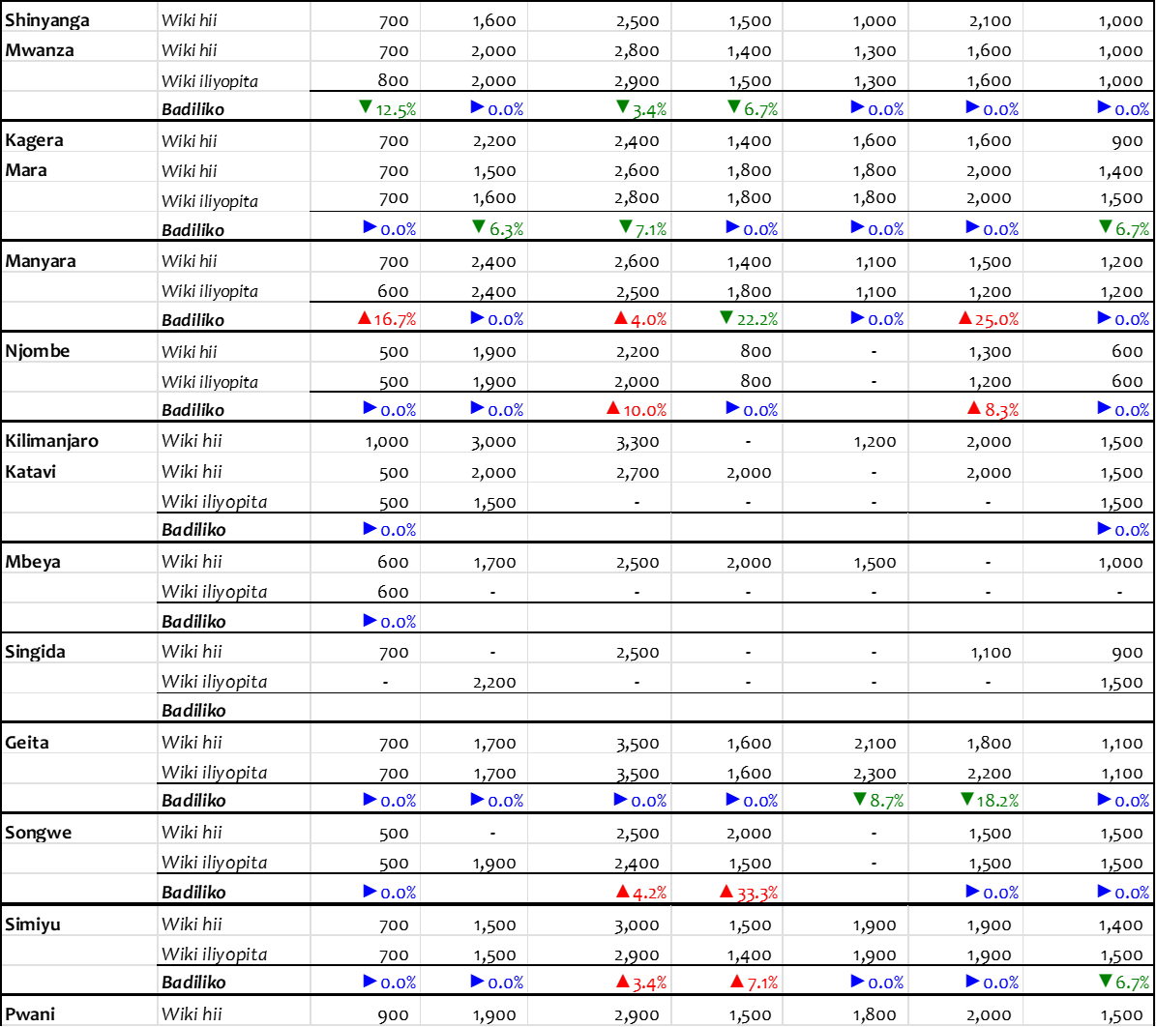

***Chanzo:*** *Wizara ya Kilimo, 2024*

***Zingatia:***

* *Bei hizi ni wastani wa bei za jumla katika soko kuu la mkoa husika.*
* *Alama (▲▼►) zinaelezea mabadiliko ya bei: (▲) bei imeongezeka; (▼) bei imepungua; (►) hakuna mabadiliko ya bei.* ✓ *(-): bei haikupatikana.*

***Jedwali 3: Wastani wa Bei (TZS) za mazao ya Horticulture katika masoko mbalimbali kwa wiki ya tarehe 04 Oktoba -09 Oktoba, 2024***

|  |  |  |  |  |  |  |  |  |  |
| --- | --- | --- | --- | --- | --- | --- | --- | --- | --- |
|  | WASTANI WA BEI ZA MAZAO YA HORTICULTURE KATIKA MASOKO MBALIMBALI(Tsh/Kg) | | | | | | | | |
| NA. | Mkoa | Wiki | Vitunguu | Nyanya | Karoti | Viazi mviringo | Kitunguu swaumu | Pilipili hoho | Tikiti maji |
| 1 | *Dar es Salaam* | *Wiki hii* | 3,200 | 900 | 1,200 | 2,800 | 12,000 | 3,500 | 750 |
| *Wiki iliyopita* | 3,200 | 700 | 1200 | 4,000 | 10,000 | 2,300 | 750 |
|  |  | %Badiliko | 0% | 29% | 0% | -30% | 20% | 52% | 0% |
| 2 | *Arusha* | *Wiki hii* | 3,400 | 400 | 2,800 | 3,200 | 9,000 | 3,000 | 670 |
| *Wiki iliyopita* | 3,600 | 600 | 1700 | 3,200 | 10,000 | 2,800 | 850 |
|  |  | %Badiliko | -6% | -33% | 65% | 0% | -10% | 7% | -21% |
| 3 | *Dodoma* | *Wiki hii* | 2,800 | 400 | 1,400 | 2,700 | 12,000 | 2,900 | 750 |
| *Wiki iliyopita* | 3,000 | 500 | 1,400 | 2,700 | 11,000 | 2,300 | 650 |
|  |  | *%Badiliko* | -7% | -20% | 0% | 0% | 9% | 26% | 15% |
| 4 | *Mwanza* | *Wiki hii* | 3,500 | 600 | 2,100 | 1,200 | 8,000 | 2,100 | 750 |
| *Wiki iliyopita* | 2,400 | 800 | 1,100 | 800 | 5,000 | 2,100 | 750 |
|  |  | *%Badiliko* | 46% | -25% | 91% | 50% | 60% | 0% | 0% |
| 5 | *Kilimanjaro* | *Wiki hii* | 2,800 | 700 | 1,300 | 2,300 | 8,000 | 3,200 | 800 |
| *Wiki iliyopita* | 3,900 | 700 | 1,300 | 1,600 | 8,000 | 2,800 | 800 |
|  |  | *%Badiliko* | -28% | 0% | 0% | 44% | 0% | 14% | 0% |
| 6 | *Manyara* | *Wiki hii* | 2000 | 400 | 1,800 | 2,000 | 6,000 | 2,700 | 600 |
| *Wiki iliyopita* | 1,700 | 400 | 1,800 | 2,500 | 5,000 | 2,100 | 600 |
|  |  | *%Badiliko* | 18% | 0% | 0% | -20% | 20% | 29% | 0% |

***Chanzo:*** *TAHA, 2024*

**Jedwali 4: Mauzo ya kakao kwa msimu wa 2024/2025 hadi kufikia tarehe 21 Oktoba, 2024**

|  |  |  |  |  |  |
| --- | --- | --- | --- | --- | --- |
|  | **Halmashauri** |  | **Kiasi kilichouzwa (Kilo)** | **Wastani wa Bei (Shilingi/Kilo)** | **Jumla (Shilingi) ch** |
| **Kyela (Kilo)** | **Busokelo (Kilo)** | **Rungwe (Kilo)** |
| 2,416,960.0 | 800,240.0 | 389,060.0 | 3,617,250.0 | 20,682.36 | 71,977,328,220.00 |

***Chanzo:*** *Tume ya Maendeleo ya Ushirika Tanzania, 2024*

**Jedwali 5: Mauzo ya kahawa kwa msimu wa mwaka 2024/2025 hadi kufikia tarehe 18 Oktoba, 2024**

|  |  |  |  |  |  |  |  |  |
| --- | --- | --- | --- | --- | --- | --- | --- | --- |
| **Aina ya Kahawa** | **Mnada** | | **Soko la moja kwa moja** | | **Viwanda vya ndani** | |  | **Jumla** |
| **Kilo** | **Dola za Marekani** | **Kilo** | **Dola za Marekani** | **Kilo** | **Dola za Marekani** | **Kilo** | **Dola za Marekani** |
| Arabika Laini | 4,345,359 | 18,900,006.66 | 10,754,902 | 50,764,352.63 | 4,883 | 23,859.36 | 15,105,144 | 69,688,218.65 |
| Arabika Ngumu |  |  | 304,440 | 1,173,204.18 |  |  | 304,440 | 1,173,204.18 |
| Robusta |  |  | 16,804,951 | 66,132,169.54 |  |  | 16,804,951 | 66,132,169.54 |
| **Jumla** | **4,345,359** | **18,900,006.66** | **27,864,293** | **118,069,726.35** | **4,883** | **23,859.36** | **32,214,535** | **136,993,592.37** |

***Chanzo:*** *Bodi ya Kahawa Tanzania, 2024*

**Jedwali 6: Miezi sahihi ya kupanda na kuvuna ili kupata bei nzuri**

|  |  |  |  |
| --- | --- | --- | --- |
| **Zao** | **Wakati unaofaa kuvuna** | **Wakati usiofaa kuvuna** | **Wakati unaofaa kupanda** |
| Vitunguu | Feb- Julai | Julai- Nov | Sept- Des |
| Nyanya | Jan- Mei | Des – Juni | Sept- Des |
| Hoho kijani | Feb- Aprili | Juni - Jan | Okt- Nov |
| Karoti | Okt- Machi | Sep - Apr | Julai- Okt |
| Matango | Feb- Mei | Mei - Jan | Des- Jan |
| Viazi mviringo | Machi- Juni | Julai - Jan | Des- Feb |
| Tikiti maji | Machi- Aprili, Oktoba - Desemba | Mei- Sep, Des- Feb | Jan- Feb, Ago- Sept |
| Hoho za rangi | Jun- Nov | Mei – Des | Feb- Machi |
| Tangawizi | Aprili- Julai | Machi – Aug | Des- Feb |

***Chanzo:*** *TAHA, 2023*

## Habari Muhimu

✓ Wizara ya Kilimo imeanzisha jukwaa la soko la mtandaoni (M-Kilimo) ili kuwezesha upatikanaji wa huduma za masoko kwa wakulima na wafanyabiashara kupitia simu zao za mkononi, jinsi ya kupata huduma ;- ❖ USSD: Piga * 152*00# chagua Na. 7 kisha Na. 2 halafu fuata maelekezo

❖ Tovuti: fungua **exts.kilimo.go.tz** kisha chagua huduma

Taarifa ya wiki ya mwenendo wa bei ya mazao ya kilimo inapatikana katika tovuti ya [**www.kilimo.go.tz**](http://www.kilimo.go.tz/)

**Kwa maelezo zaidi wasiliana na:** Sehemu ya Masoko ya Mazao,Wizara ya Kilimo,S.L.P 2182, DODOMA. Barua pepe: **masoko@kilimo.go.tz**